Tableau Lab Task

Exercise 1
- Import Retail_Store.csv into Tableau.
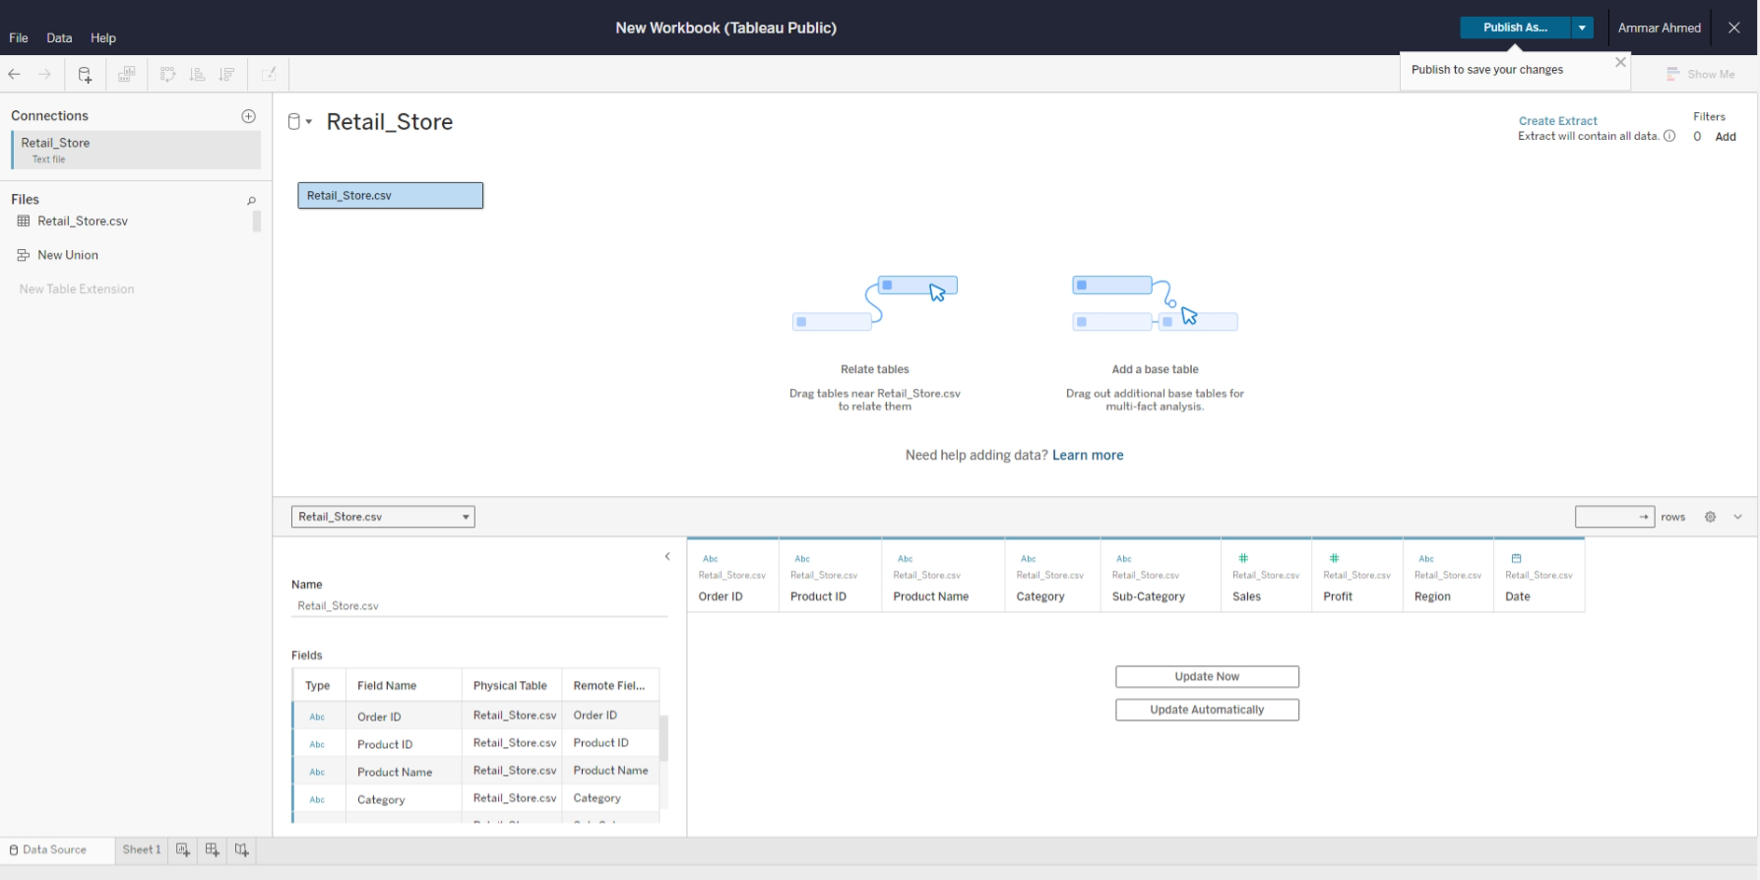
- View the number of rows and columns in the dataset to understand its size.
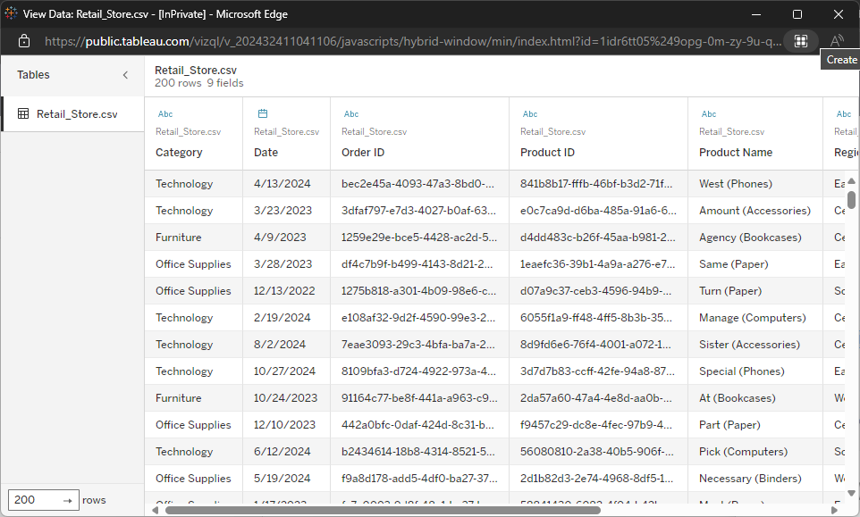
3. Calculate the total sales and average profit using Tableau's SUM and AVERAGE functions.
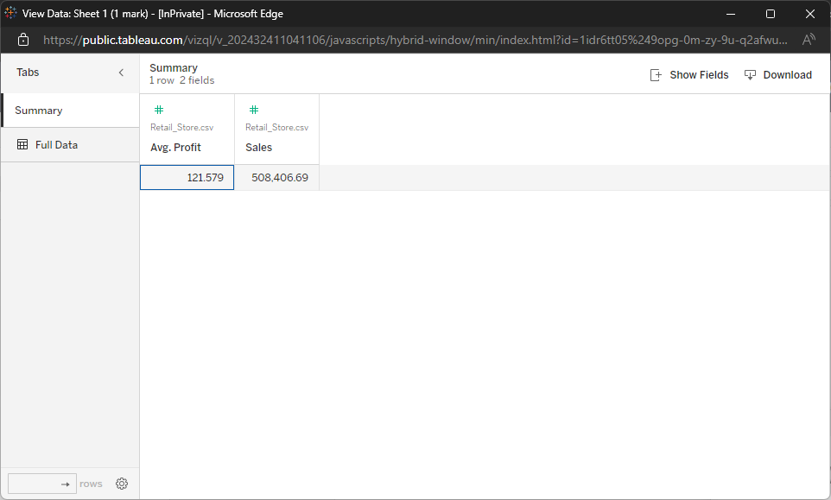
4. Check for null values or missing data fields.
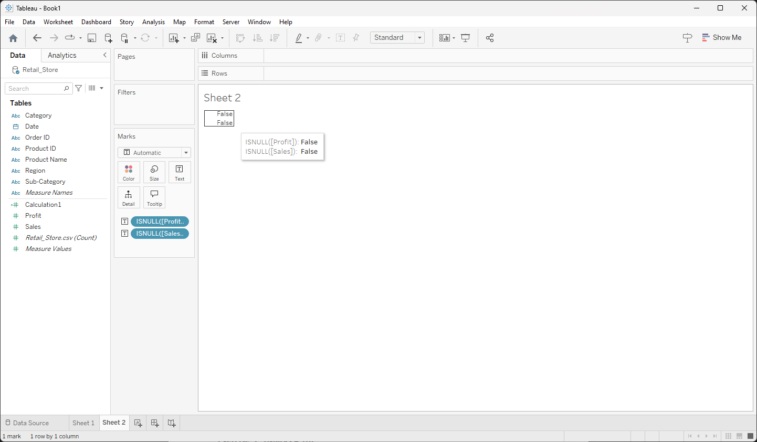

Exercise 2
- Create a barplot with X-Axis: Category and Y-Axis: Sum of Sales.
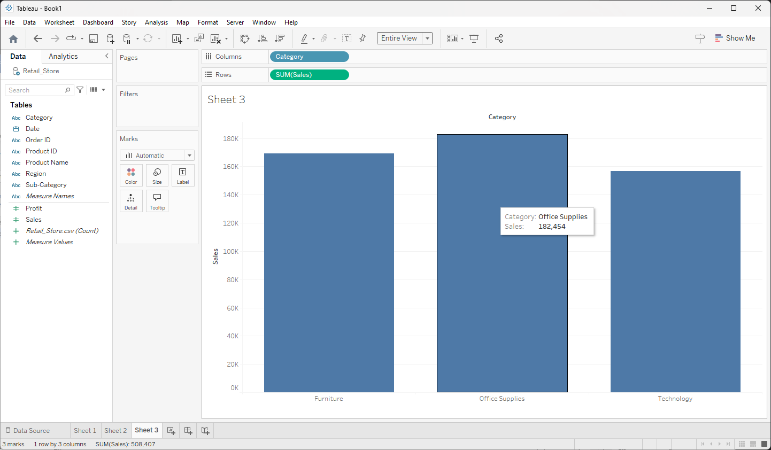
- Create a lineplot with X-Axis: Date and Y-Axis: Sum of Sales
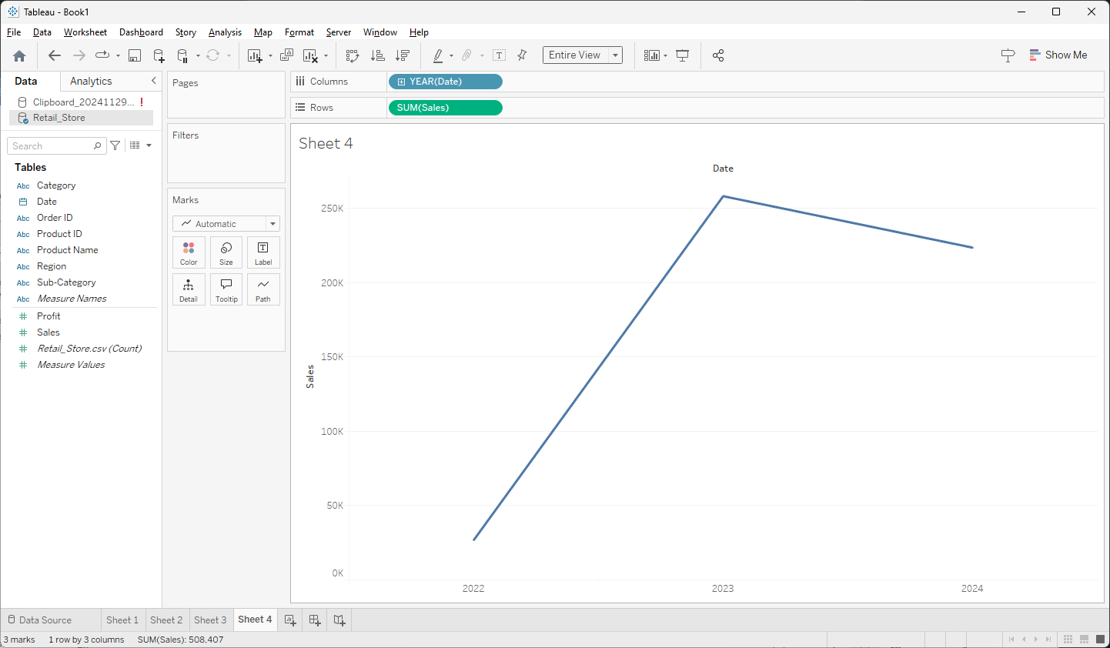
3. Create a pieplot with Show sales proportions by region with Slices based on:
Sales and Color-coded by: Region
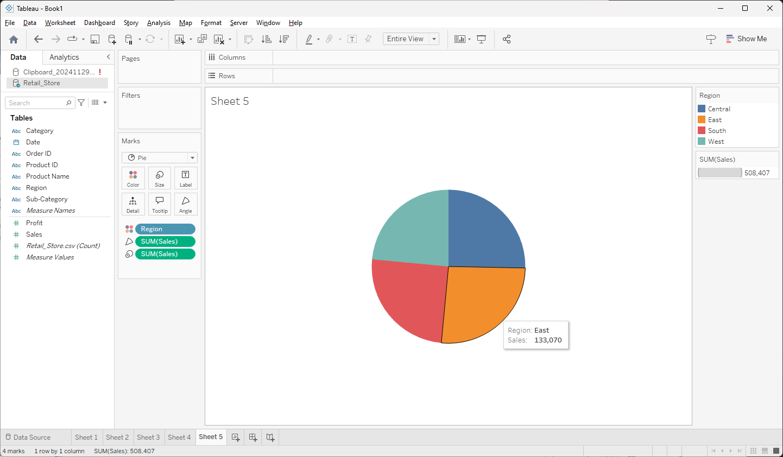

Exercise 3
- Inner Join Retail_Store.csv and Customer_Info.csv on Customer ID.
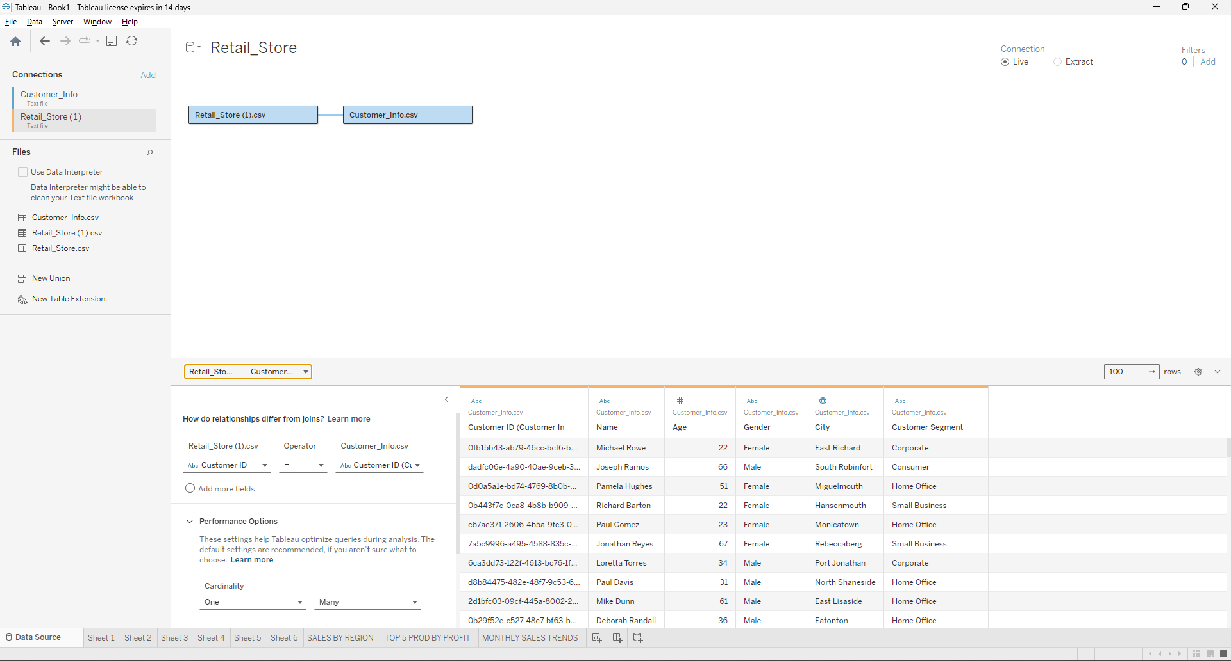
- Filtered Line Chart: Filter sales trends by customer segment (e.g., Consumer, Corporate).
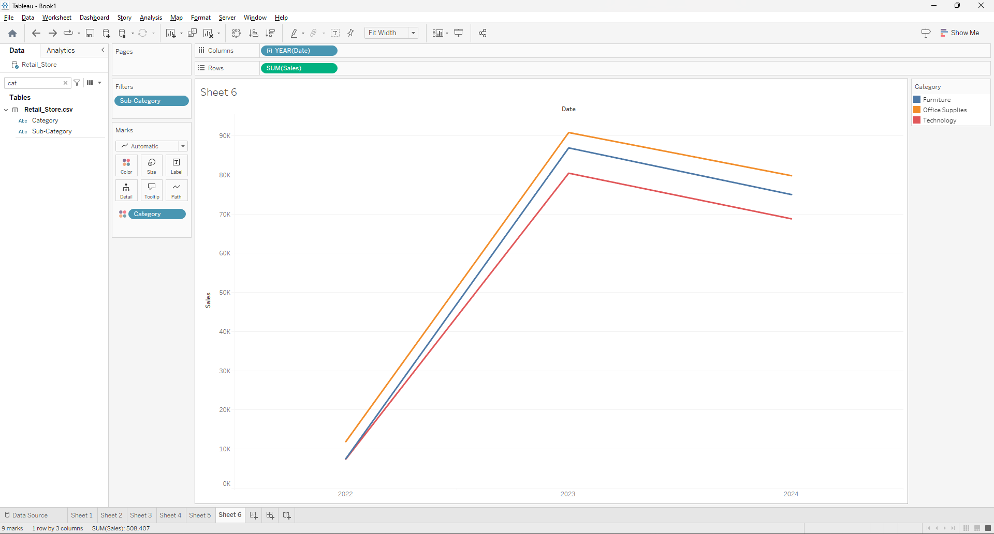

Exercise 4
Combine multiple views:
1. Map showing sales by region.
2. Bar chart of top 5 products by profit.
3. Line chart of monthly sales trends.
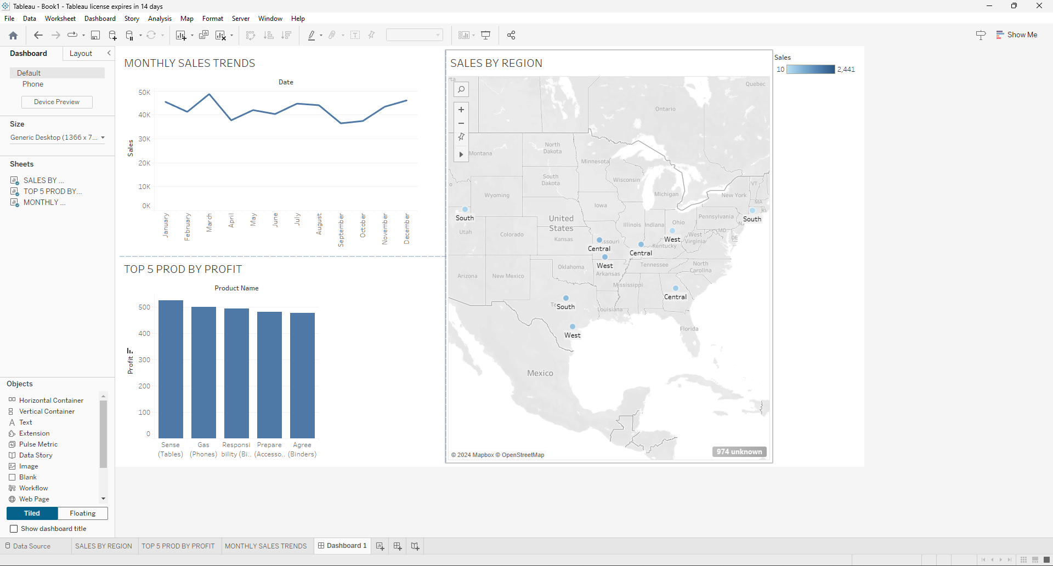

Exercise 5
- Add a calculated field Margin such as Margin= (Profile/Sales)*100
- Now plot Margin region-wise. You can suggest appropriate plot here.
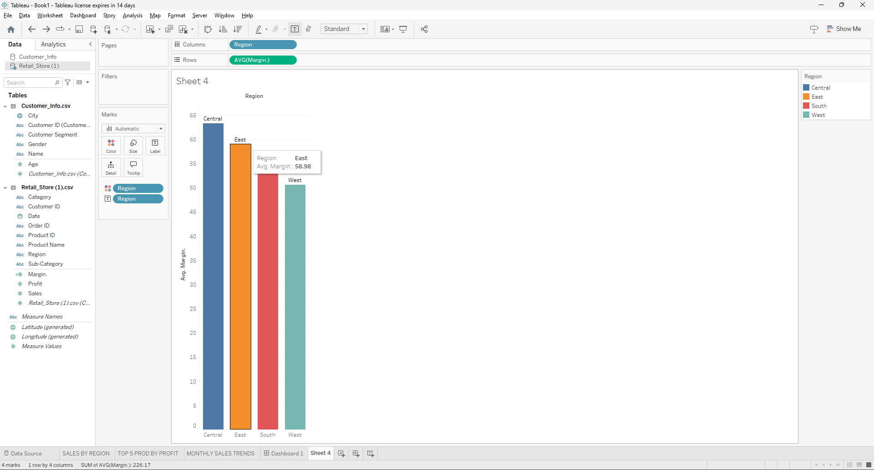

Exercise 6
Create a Geographic map to display sales by state.
